34 Hill Street, Rockley NSW 2795
Tel: 02 6337 9336
Email: rockley-p.school@det.nsw.edu.au
Website: https://rockley-p.schools.nsw.gov.au

Term 3 Week 6 2023 Newsletter

ROCKLEY PUBLIC SCHOOL

Principal’s Report

Dear Parents

This past fortnight we have seen most, if not all students playing soccer together each break. It is fantastic to see students across all ages playing together and being active. It has also, however, given rise to some unsportsmanlike conduct, with teachers regularly reminding students of appropriate behaviours at school. A part of what makes our school so wonderful is we are multi-age and students generally celebrate each other's success without competition. Discussions around sport and soccer in particular is a great opportunity for parents to have conversations at home around what is fair isn’t necessarily what is equal.

BASC Update
A survey has been issued to families via Facebook to please complete. This is to ensure ASPIRE has an up-to-date profile of the service our families require. This service may also be available to local children in the community that attend other schools. We will communicate the results of the survey along with any additional information as soon as it becomes available.

This week students enjoyed a master class in photography from professional photographer Zenio Lapka. Zenio has had a career in photographing motor sports and professional athletes, while some locals may remember him from his time at the Western Advocate. With these new skills, our students are enthusiastic about showcasing their photographs at the Arts and Gardens weekend.
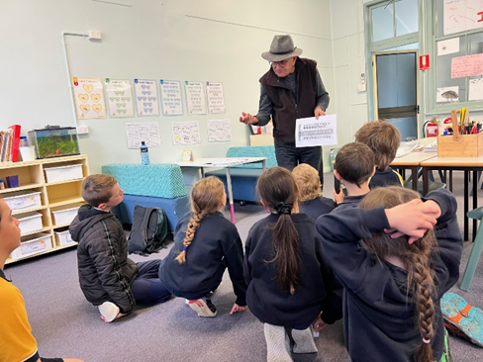

Mrs Knipe
Relieving Principal

No Hat Play in the Shade
We continue to enforce this message daily and all families are reminded to ensure that your child/children are bringing a suitable hat to school daily, particularly as the weather warms.

Parent / Teacher Interviews
Parent teacher interviews will take place in Week 8. Attached to today’s newsletter is a booking sheet. Please return your sheet as soon as possible and every endeavor will be made to accommodate your preferred time slot. These interviews are a great opportunity for parents to learn about how their child/children is experiencing school this semester and to ask any clarifying questions.

Bushfire preparation
As previously advised our school is categorised as a Category 2 school. Therefore, there may be a possibility that the school may be directed to temporarily cease operations in times of fire danger. Parents should stay up-to-date with bushfire and grassfire activity by using the Hazards Near Me app and set your watch zone to include the school in the upcoming season.

Book Week Parade
Thank you to the parents and carers who attended our book week parade. Students always love to see their family members in the crowd and it’s fantastic to see so many families supporting school events as possible. Congratulations to Grace and Savannah for your Excellence in Reading awards.

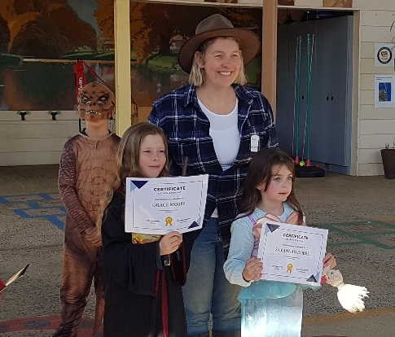

Homework
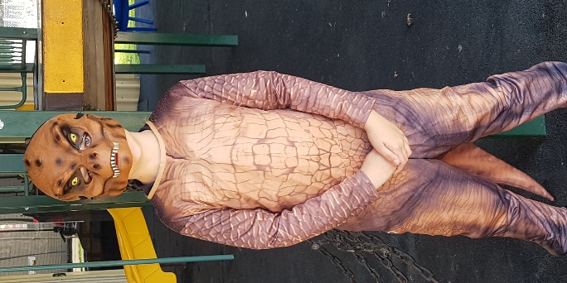
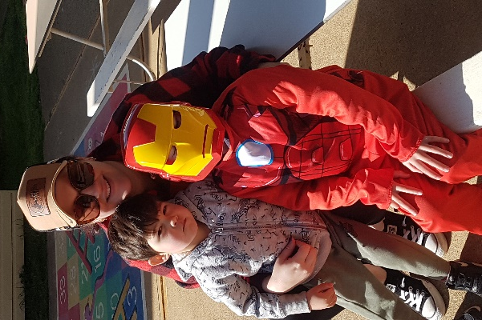
Thank you to all those students who completed and returned their geography homework last week.
If any students desire additional homework, there is maths, reading and a research project assigned on Google Classroom.

School Photographs – Wednesday 13th September
A reminder that photograph orders can either be ordered on line using the individual shoot key which was on your child’s envelopes when sent home. Also, those families requiring a family picture of siblings together should request a family order form from the office.

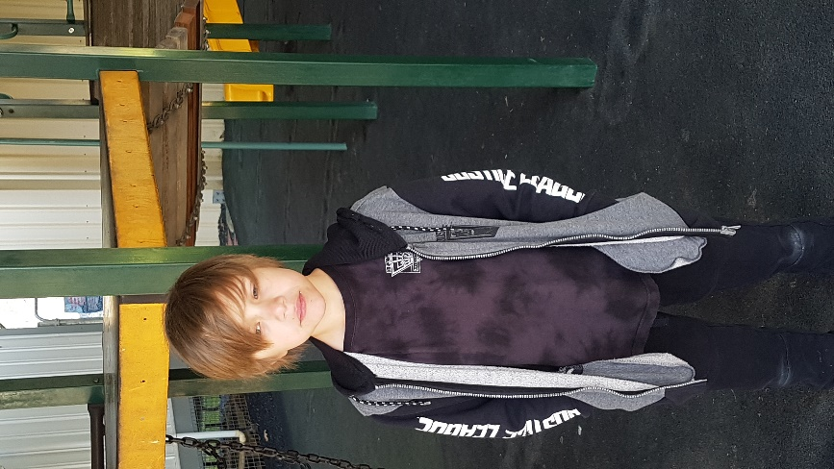
Dental Clinic Check Up
Please return your families form prior to the 11th September. Please notify the school if you do not wish to have your child/children’s teeth checked.
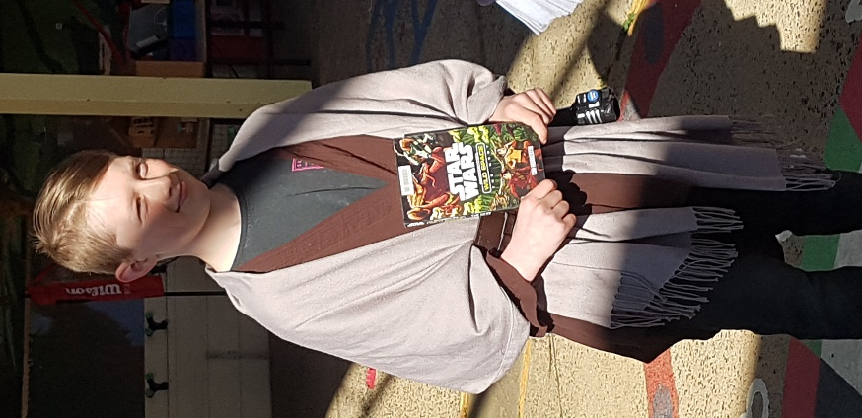
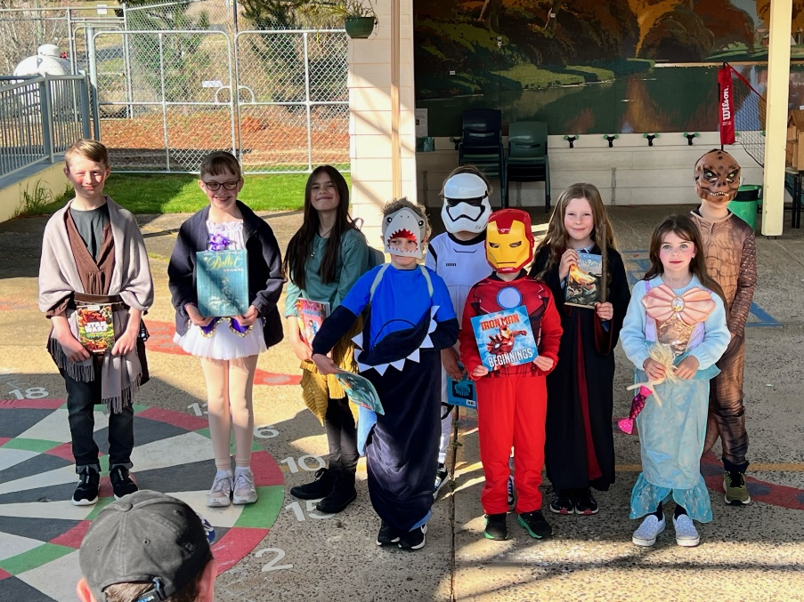

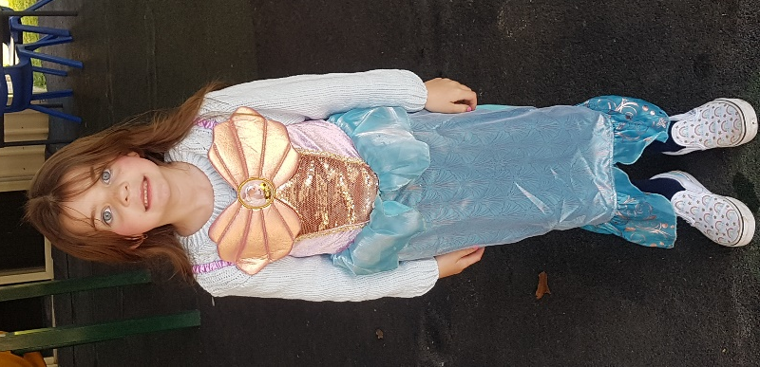
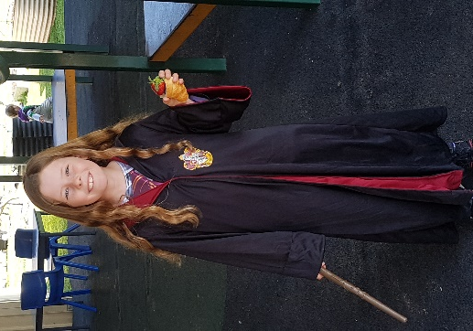
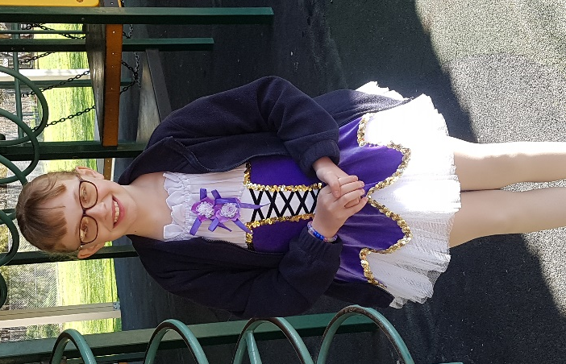
School Behaviour Management
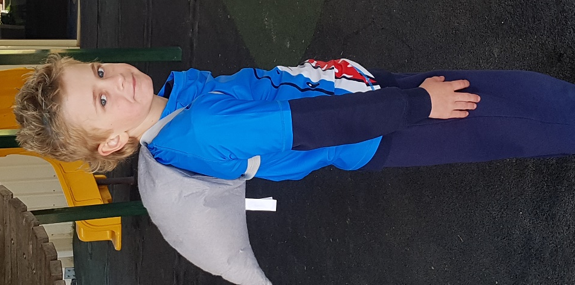
Our school behaviour management plan reminds students to make positive choices throughout their day. Each fortnight, staff and students recognise students who consistently try to make positive choices in their behaviour and learning.
Positive Behaviour for Learning (PBL) focus:
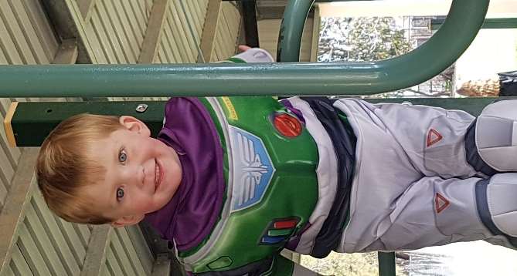
Speaking respectfully to all
Respectful | Follow adult instructions  Listen carefully, face the speaker and remain quiet while others are talking.  Use a quiet, polite voice when replying
Responsible | Allow others right of reply and respect their opinions.  Don’t interrupt the conversations of others.  Raise your hand to ask a question
Safe | Follow adult instructions  Offer solutions in a respectful manner

Dates for your diary:
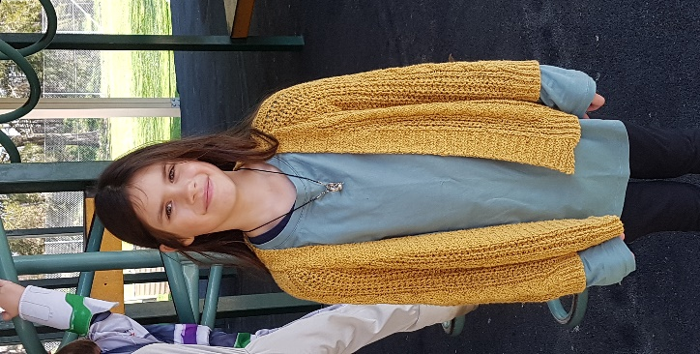
6th/7th September – Parent/teacher interviews
13th September – Photo Day
11th September – Dental Check form due in
29th September – Term 3 ends

P and C Information
A meeting will be held shortly where discussions will continue in regard upcoming events with some items needing to be finalised.
Notification will be sent home next week.

8th October – Markets
21st October – Classic Motorbike Catering
11th November – Arts & Gardens Festival Weekend

Please keep some time to assist at any/all of these upcoming events so the P & C can continue to support your child’s education here at RPS.

