34 Hill Street, Rockley NSW 2795
Tel: 02 6337 9336
Email: rockley-p.school@det.nsw.edu.au
Website: https://rockley-p.schools.nsw.gov.au

Term 1 Week 8 2022 Newsletter

ROCKLEY PUBLIC SCHOOL

Principal’s Report
Dear Parents,
Welcome to our Week 8 Newsletter. Apologies that there was no Week 6 newsletter due to time constraints and printing issues.

Staff Movements
As you would all now be aware, Ms. Quinn finished her time here at RPS last Friday. The students presented Ms. Quinn with a lovely bunch of flowers and wished her well in her future endeavours which we believe may include a sea-change!
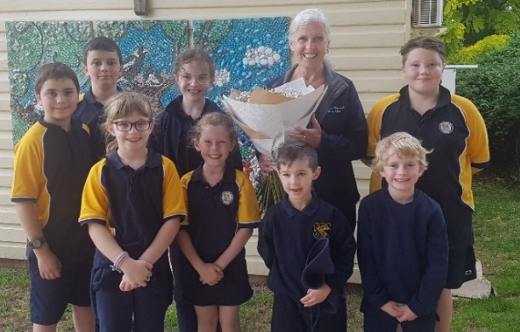

Over the next two weeks we will have two new casual teachers joining us, Ms Matthews and Ms Youman. Ms. Youman is an ex-student and we look forward to hearing how things have changed at Rockley since her last visit. I am sure you will join with me in making them most welcome.

I wanted to say a special thank you to everyone for making me feel so welcome. The strong sense of mateship, pride and community is so evident and I feel incredibly privileged to be part of this kind, caring and thoughtful community. Our students have already made such great progress this term which is a tribute to the hard work of our wonderful staff, students and families.

On behalf of myself and Mrs Watson I would also like to thank those parents who have been able to set aside time for their child/children’s Parent Teacher interviews. These interviews are invaluable in assisting us to plan for your child’s learning. Thank you.

Mrs Fran Knipe
Relieving Principal

REMINDER -/Fruit Break/Hats/Water Bottles/Homework
It is fantastic that our bubblers have finally been restored to a working condition but we still recommend that students bring a water bottle to school to have on their desks for regular hydration.

It is also important that your child have a piece of fresh fruit/veggies for Fruit Break each morning.

Hats are also an important daily item which children should have with them particularly on Wednesdays for sport.

Mosquitoes continue to be an issue in and around the playground. A repellent (Rid) is available for those children who need it or alternatively a roll on may be sent in from home, clearly marked with your child’s name and this will be stored in the office for their personal use. We also have antiseptic spray which we can use for children who are bitten. If you DO NOT want your child to use either of these products please ring the office immediately to advise of this.
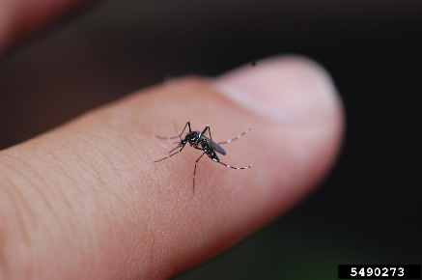

A reminder that all students have been provided with a homework contract book as requested by parents earlier this year. These books need to be returned on Fridays for marking and will be re-issued on Mondays.
Students Yrs2-Yr6 also have spelling lists to be completed daily. Kindergarten have readers which they should read with an adult daily.
If there are any problems please do not hesitate to let your child’s teacher know.

School Behaviour Management Plan
The Positive Behaviour for Learning (PBL) focus for this week will be:
Caring for your each other and respecting others choices
SAFE | Making sure your peers and younger students understand safety considerations
RESPECTFUL | Respect others opinions and choices (unless its unsafe or unkind). Include others in play and activities.
RESPONSIBLE | Tell staff if there is a problem in the class or playground. Ensure you know what is expected in any activity or learning experience.
CONGRATULATIONS!
“PBL Student of the Fortnight- Week 6 Staff Award”
Speaking Respectfully
Sarah
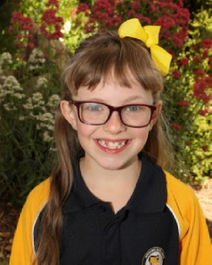

CONGRATULATIONS!
“PBL Student of the Fortnight-Week 6 Peer Award”
Speaking Respectfully
Tanner
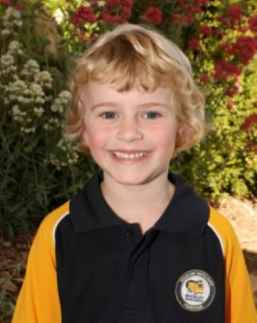

CONGRATULATIONS!
Positive Platypus Merit Award Lucky Draw Winner Week 6
Sarah
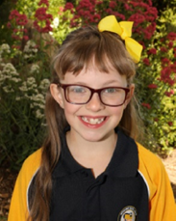

Sarah organised some fantastic dance and fitness routines throughout the week.

CONGRATULATIONS!
“PBL Student of the Fortnight- Week 8 Staff Award”
Positive Attitude to Learning
Grace
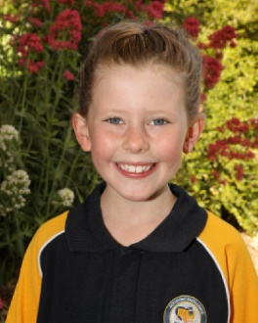

CONGRATULATIONS!
“PBL Student of the Fortnight-Week 8 Peer Award”
Positive Attitude to Learning
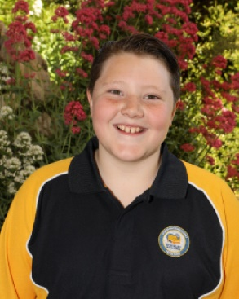
Edward

CONGRATULATIONS!
Positive Platypus Merit Award Lucky Draw Winner Week 8
Tanner
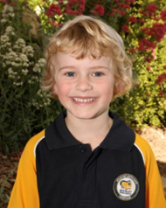

Tanner will have a lucky dip today!

Stage 3 Camp
Monday – Wednesday next week. Separate information has been provided for the Year 6 students. Look out Canberra – here we come!!
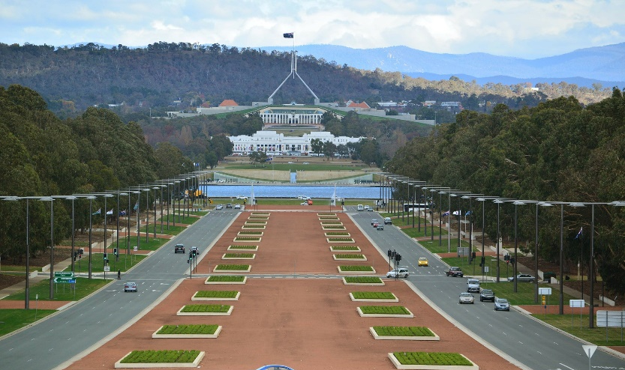

Sustainable Practices
The students and staff have been working hard to recycle materials at school. Attached to this newsletter, please find some details about our latest ventures
- Mobile Muster
- Wonder Recycling Rewards (bread bags)

We will also soon have details of a fundraiser selling wax wraps which replace sandwich bags and glad wrap. Watch out for these details soon.

Anzac Day 2022
We will once again be taking part in the Anzac Day Memorial march and service on the 25th April. It would be greatly appreciated if as many students as possible could participate in this well attended community event. We will send further details in the Week 10 newsletter.

Easter Hat Parade
We are looking at a slightly different format for this year and we are certainly looking forward to having our families involved in this activity. Details will be provided in Week 10’s newsletter. Please keep Friday 8th April free to
join us.

P and C News
A big thank you to everyone who helped out with the Bunnings BBQ last Sunday. A $1000 profit was an excellent result.

Upcoming Dates are:
- Saturday 9th April – Catering Motorbike Rally – Rockley Sportsground
Lunch for approximately 40 travelling bike riders. This will involve a BBQ lunch and salad, followed by slices, sweets etc. Please let Leanne know as soon as possible if you are able to help in any capacity ie cooking/set up/making sweets.

- Sunday 10th April – School/P & C Stall – Rockley Artisans Market
Do you have any goodies we can sell at our stall such as seedlings, jams, pickles, craft items etc? We are also looking at holding an Easter Raffle and donations of items suitable for an Easter basket would be appreciated. Also volunteers keen to man the stall should contact the office asap.

Term 1 dates for your diary:
- Caring for our Waterways Incursion – 18th March
- Stage 3 Camp – 21st March
- MusicaViva Incursion – 24th March
- BSS Gala Day 7th April
- Easter Hat Parade and Celebration 8th April
- Term ends 8th April
- P and C Motorbike Rally Catering 9th April
- P and C Stall/Artisans Markets 10th April
- ANZAC Service 25th April
- SDD Term 2 26th April
- Students Return 27th April

