34 Hill Street, Rockley NSW 2795
Tel: 02 6337 9336
Email: rockley-p.school@det.nsw.edu.au
Website: https://rockley-p.schools.nsw.gov.au

Term 1 Week 10 2022 Newsletter

ROCKLEY PUBLIC SCHOOL
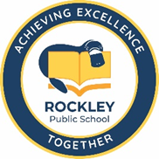

Principal’s Report
Dear Parents,

I’d like to congratulate all our students on their hard work and dedication to learning this term.
Our kindergarten students have settled in seamlessly and have learned so much in such a short amount of time. They can now count to 20 and they have started blending their sounds to read three and four letter words.

In Years 2-4, our students have completed their NAPLAN readiness test and Check-In Assessments. They are making great strides when adding detail to their narratives and in mathematics they have learned to find fractions of a whole number.

Our Stage 3 students have made both teachers and families alike incredibly proud as they have shown such maturity, resilience, understanding and commitment to learning this term. These students are the embodiment of leadership and they are a testament to their families and the school.

This is the last newsletter for Term 1. As such I would like to wish everyone a restful and safe holiday period. We will recommence school on Tuesday 26th April with students resuming on Wednesday 27th April.

Mrs Fran Knipe
Relieving Principal

Year 6 Camp
What a fantastic time our Year 6 students had in Canberra as part of the BSS Stage 3 camp. It was extremely unfortunate that Edward was unable to enjoy the full camp but I know that the time he had with the other students was very enjoyable. I have received an email from another school teacher who said that “Your students were divine in Canberra, would take them away any time”. Mrs Watson and I are so very, very proud of you all. Well done!

Whilst in Canberra, students participated in a variety of educational programs with a focus on Australia’s history, culture, heritage and democracy. The Australian Government

recognises the importance of all young Australians being able to visit the national capital as part of their Civics and Citizenship education. To assist families with the cost of the excursion the Australian Government contributes $30 per student under the Parliament and Civics Education Rebate program towards those costs. The rebate is paid directly to the school.

School Behaviour Management Plan
The Positive Behaviour for Learning (PBL) focus for this week will be:
Caring for each other and respecting others choices
SAFE | Making sure your peers and younger students understand safety considerations
RESPECTFUL | Respect others opinions and choices (unless its unsafe or unkind). Include others in play and activities.
RESPONSIBLE | Tell staff if there is a problem in the class or playground. Ensure you know what is expected in any activity or learning experience.
CONGRATULATIONS!
Last week we recognised our Year 6 students for their wonderful maturity and fantastic representation of our school. Well done Edward, Indiana and Lila.
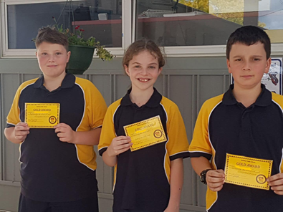

CONGRATULATIONS!
Positive Platypus Merit Award Lucky Draw Winner
Terence (T.J)
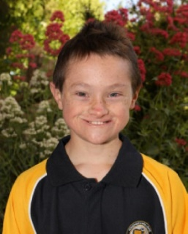

TJ chose a prize from the lucky dip box

Gala Day
Students from Years 2-6 will be participating in Gala Day on Thursday 7th April at Learmonth Park, Kelso. Mrs Watson will accompany the children. They will be participating in cross country and soccer and touch football trials. Please ensure students have plenty to drink and enough food for the day. Transport is by private arrangement.
Kindergarten students will attend school with Mrs Knipe as per normal.

Easter Hat Parade
Friday 8th April. Students will march from school to Stevens Park where they will participate in some fun Easter activities. This will culminate in an Easter egg hunt! Families and interested community members are invited to join us at the park from 2:15pm. Please ensure your child brings their Easter hat creation to school that morning. Younger siblings are also encouraged to participate. Any questions please call the school.

Anzac Day 2022
We will once again be taking part in the Anzac Day Memorial march and service on the 25th April. It would be greatly appreciated if as many students as possible could participate in this well attended community event. Please meet staff at the Mill Museum at 8:20am in full school uniform. At the conclusion of the service please feel free to join us for refreshments.

Anzac Day March
Could all students please meet teachers at the Mill Museum on 25th April at 8:15am. Full school uniform is required please. Wreaths will be available for the students to lay and families may wish to join us for a cuppa after the ceremony. Please bring a morning tea plate to share.
Any questions please call Leanne 0403195796

Upcoming Dates are:
- Saturday 9th April – Catering Motorbike Rally – Rockley Sportsground
Lunch for approximately 40 travelling bike riders. This will involve a BBQ lunch and salad at approximately 11:30am, followed by slices, sweets etc. Please let Leanne know as soon as possible if you are able to help in any capacity ie cooking/set up/making sweets.

- Sunday 10th April – School/P & C Stall – Rockley Artisans Market
Do you have any goodies we can sell at our stall such as seedlings, jams, pickles, craft items etc?

We are also looking at holding an Easter Raffle and donations of items suitable for an Easter basket would be appreciated. Also volunteers keen to man the stall should contact the school office asap.

Term 1 dates for your diary:
- BSS Gala Day 7th April
- Easter Hat Parade and Celebration 8th April
- Term ends 8th April
- P and C Motorbike Rally Catering 9th April
- P and C Stall/Artisans Markets 10th April
- ANZAC Service 25th April
- SDD Term 2 26th April
- Students Return 27th April

