34 Hill Street, Rockley NSW 2795
Tel: 02 6337 9336
Email: rockley-p.school@det.nsw.edu.au
Website: https://rockley-p.schools.nsw.gov.au

Term 1 Week 4 2022 Newsletter

ROCKLEY PUBLIC SCHOOL

Principal’s Report

Dear Parents,
Welcome to our Week 4 Newsletter.

Staff Movements
Yesterday students and staff had the opportunity to welcome Mrs Fran Knipe to the school. Mrs Knipe will start as Principal as of next Monday. She will be working in the Koala classroom with our Kindergarten students, ensuring they have a smooth transition to school and instilling their early learning concepts which are imperative to development throughout their primary years.
Mrs Knipe comes to us with a wealth of experience across all ages both in local schools and Sydney schools. I know everyone will make her feel most welcome.

I would also like to take the opportunity to thank Mrs Janelle Sennett who has stepped into the Koala teaching role over the last two weeks at short notice. Mrs Sennett will also be returning to Rockley on occasions when casual staffing is required and her knowledge and support during my weeks as relieving Principal has been invaluable. Thank you Mrs Sennett.

I would also like to thank the other wonderful staff for their support (and patience!) during my period as relieving Principal. Thank you.

Mrs Tracey Watson
Relieving Principal

REMINDER -Hats/Water Bottles/Homework
Please ensure that your child is bringing a water bottle to school each day. We have refill spots available throughout the school for all to use.
All students are expected to wear a hat daily. This is imperative during this warmer weather and particularly when playing sport on a Wednesday. Sunscreen is also available in the office foyer for all to use.
Mosquitoes have been an issue in and around the playground. A roll-on repellent may be sent in, clearly marked with your child’s name and this will be stored in the office for their personal use.
Homework book need to be returned on Fridays for marking and will be re-issued on Mondays. The Year 6 books have arrived and will be sent home next Monday.

PBL – Monday’s
As PBL lessons will involve lots of ‘hands-on’ activities most Monday afternoons, it is suggested that students bring in old shirts (perhaps old Rockley uniform shirts) and wear old shoes so that they can change prior to the afternoon sessions.

School Behaviour Management Plan
The Positive Behaviour for Learning (PBL) focus for this week is:
to speak respectfully to peers, adults and family
SAFE | Advising others of safe play instructions respectfully  Following instructions quickly and respectfully
RESPECTFUL | Using kind words and good manners when speaking to people  Answering both peers and staff in a respectful manner  Speak to others the way you would like to be spoken to
RESPONSIBLE | Assure that your tone and mannerisms reflect respect.
CONGRATULATIONS!
“PBL Student of the Fortnight- Staff Award”
Consistent effort to follow instructions.
Indiana Williams
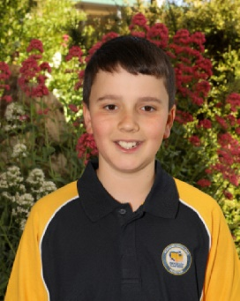

CONGRATULATIONS!
“PBL Student of the Fortnight- Peer Award”
Consistent effort to follow instructions.

Lila Williams
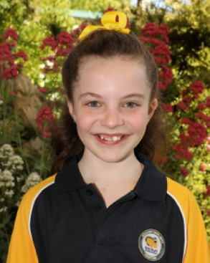

CONGRATULATIONS!
Positive Platypus Merit Award Lucky Draw Winner

Grace Mobbs
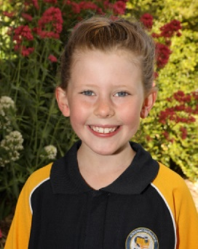

Grace has chosen to pick fitness activities for the week.

Exciting News! – Turtle Pond
The much anticipated turtle pond has been ordered and is expected to be delivered in approximately 4 to 6 weeks. The students will start to assist in the cleaning of the area in PBL lessons.
We look forward to being able to welcome parents and visitors back into our school in the near future to help us with this project.

School Pets
Our lovely little silkie has 6 chickens and students have been excited to have a hold this week. We hope they grow into beautiful hens to increase our flock. Our larger chooks are still laying and we hope to have their eggs to use in future cooking lessons.
The budgies are nesting again and some nice little chicks can be expected in the future. A big thank you to Kathy & Jeramee for their kind donations of feed towards our pets.

Stage 3 Camp
Parents are reminded that final payments will become due next week. Details are being locked in and a list of requirements and revised itinerary will be sent home as soon as possible.

P and C News
Upcoming events

- Sunday 13th March – Bunnings BBQ
Please let Leanne know if you can assist with this event. We are very lucky to have secured this booking so we need to make sure we have enough parents/carers available to staff the stall etc. Thank you.

- Saturday 9th April – Catering Motorbike Rally – Rockley Sportsground
Lunch for approximately 40 travelling bike riders. Details to follow shortly.

- Sunday 10th April – School/P & C Stall – Rockley Artisans Market
Details to follow shortly.

Term 1 dates for your diary:
- P and C Bunnings BBQ – 13th March
- Stage 3 Camp – 21st March
- MusicaViva Incursion – 24th March
- P and C Motorbike Rally Catering 9th April
- P and C Stall/Artisans Markets 10th April

